Crawford Smith & Swallow is committed to having an emergency plan in place for each of our locations to assist staff and the public to respond in the event of an emergency.

EMERGENCY RESPONSE TEAM

Emergency Co-ordinator: Kathy Weier - extension 2352
Alternate Emergency Co-ordinators: Kyler James - extension 2354
Carley Kell - extension 2353
First Aid Response Team: Karen Olsen - extension 2350

VOICE COMMUNICATION SYSTEM – Contact reception at extension 2350 if you become aware of an emergency situation and/or just tell everyone in the office.

FIRST AID KIT

The first aid kit is located in the bottom drawer of the cabinet where the office supplies are kept.
An eye wash station is located in the kitchen mounted on the sink tap.

EMERGENCY PHONE NUMBERS

EMERGENCY 911
POLICE (NON-EMERGENCY) 905-688-4111
FIRE DEPARTMENT 905-468-3266
HOSPITAL 905-378-4647
POISON CONTROL 1-800-222-1222
Alarm System: Regional Signal 905-346-2933
Gas Company: contact Embridge 1-866-763-5427
Electric Company: contact NOTL Hydro 905-468-4235
CONTRACTORS
Electrician: contact Gordon Wright 905-356-5730
Plumber: contact John Dyck 905-468-7364 / 905-328-5720
Roofer: contact John Dyck 905-468-7364 / 905-328-5720
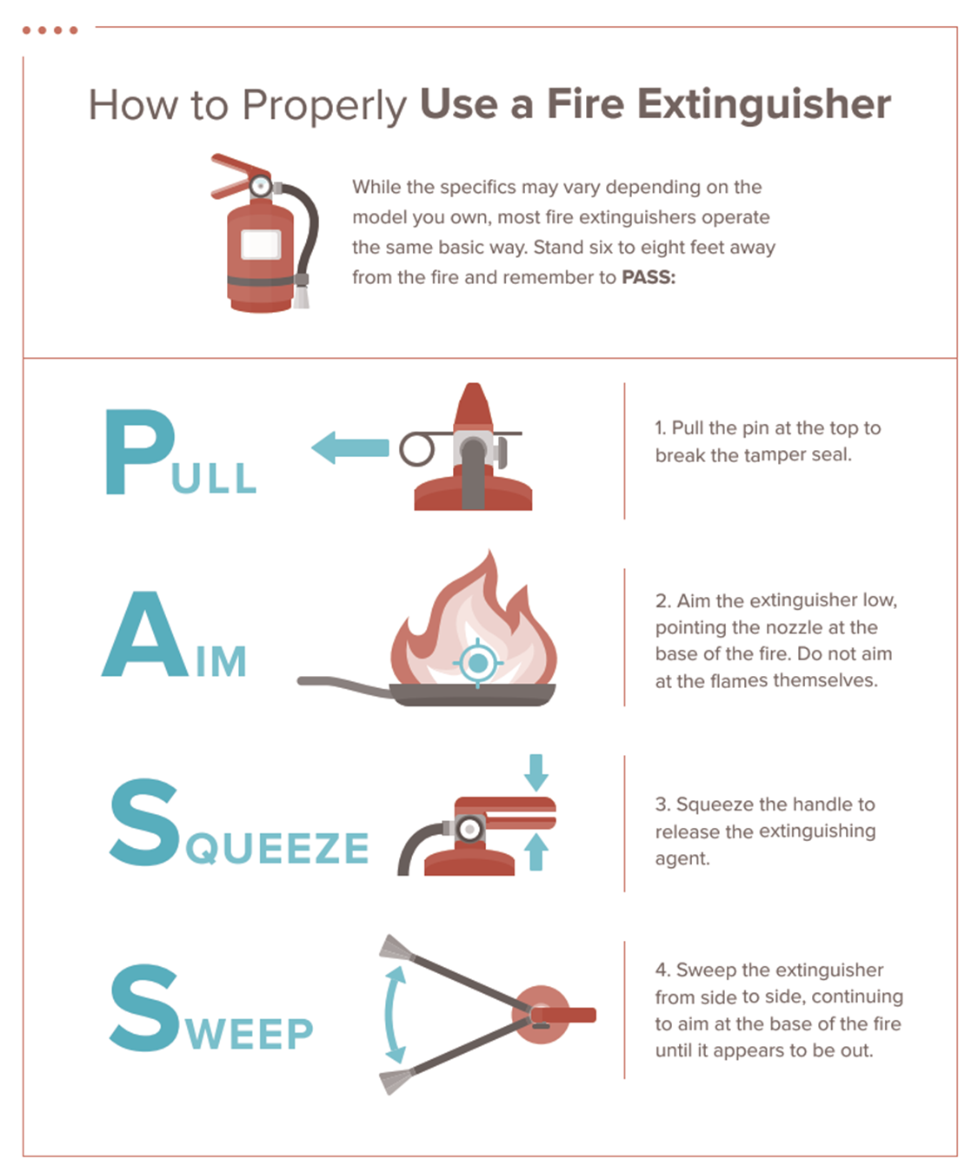

OFFICE MAP:
LOCATIONS OF FIRE EXITS, FIRE EXTINGUISHERS AND FIRST AID KIT

MAIN FLOOR
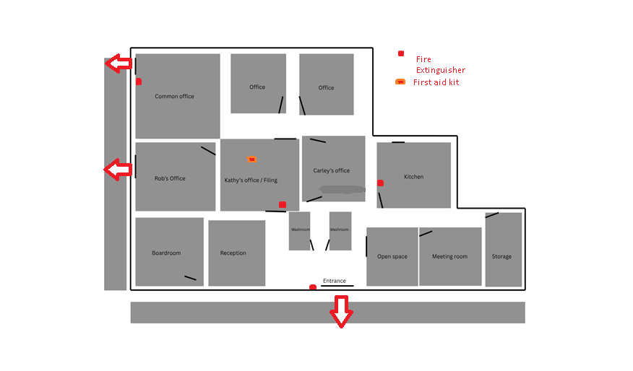

LOCATIONS OF FIRE EXITS, FIRE EXTINGUISHERS AND FIRST AID KIT

EMERGENCY PROCEDURES FOR ALL OCCUPANTS
FIRE/EXPLOSION
Upon discovery of fire or smoke:
- REMAIN CALM
- Leave affected area immediately, alerting your coworkers
- Close all doors behind you
- Alert reception so they can call 911 and use the Voice Communication system to alert other staff members
- Leave the building using the nearest exit
Upon hearing the alarm:
- REMAIN CALM
- Alert reception
- Begin to evacuate immediately
- Close all doors behind you
- Follow instructions broadcast over
the Voice Communication system
Fight the fire ONLY if:
- The Fire Department has been notified
- The fire is small and is not spreading to other areas
- Escaping the area is possible by backing up to the nearest exit
- The fire extinguisher is in working condition and personnel are trained to use it
MEDICAL EMERGENCY
In the event of a medical emergency:
- Call 911
Provide the following information:
- nature of the medical emergency
- location of the emergency (address, incident location)
- Have someone alert Reception and retrieve the First Aid Kit
- Do not move the victim unless absolutely necessary
- Reception will call the personnel trained in CPR and First Aid to provide the required assistance prior to the arrival of the First Responders
EMPLOYEE MEETING AREA
In case of an emergency where evacuation of the building is necessary, all employees will move directly to the nearest/safest exit and proceed to the “Outside Meeting Spot”. Meet in the parking lot on the southwest side of the building.
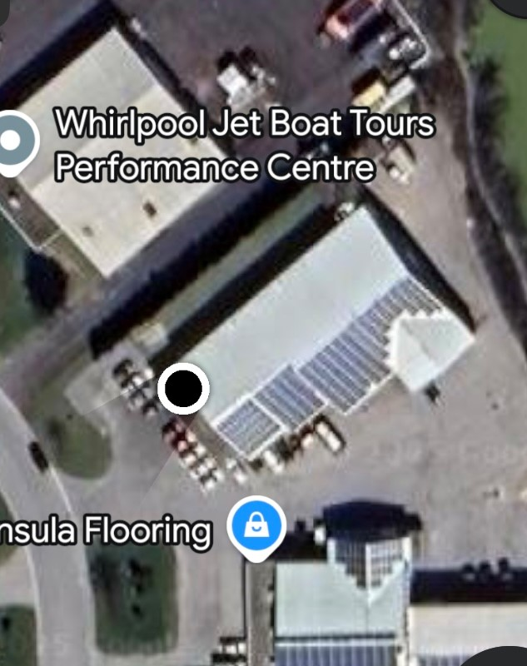

CIVIL UNREST/HUMAN THREAT
In the event of a threat of violence from outside:
- Ensure exterior doors are locked
- Alert reception so they can call 911 and use the Voice Communication system to alert other staff members
- Move away from windows and doors
- Follow instructions broadcast over the Voice Communication system
- Remain inside the building until deemed safe by law enforcement

In the event of a threat of violence inside the office:
A - If you witness a potential threat:
- Remain calm and discreetly alert a Emergency Coordinator.
- Provide details such as the location, description of the individual, and nature of the threat.
- Avoid escalating the situation by maintaining a non-confrontational demeanor.
B. If there is an active threat:
- Run:
- Evacuate the building immediately if it is safe to do so.
- Leave belongings behind.
- Warn others along your escape route.
- Hide:
- If evacuation is not possible, find a secure location out of the attacker’s view.
- Lock and barricade doors, turn off lights, silence electronic devices, and stay quiet.
- Do not open the door until law enforcement confirms it is safe.
C. Reporting:
- Call 911 when it is safe, providing clear details about the situation.

