- Materiality will not be disclosed in the audit planning letter (416F). The audit planning letter will indicate that the materiality will be provided at the end of the audit through the audit findings letter (345F). These have been updated in the audit CaseWare template, available through document library
  - Purpose: to reduce risk of fraud as management would not know the testing threshold before the start of the audit

- Prior years FS - should be brought into current year file from now on- logic is that you use this to agree to current year FS comparatives. Placeholder included in audit template.

- Preliminary Analytical Review (PAR) and Final Analytical Review (FAR). There are sample templates available in the audit CaseWare file
  - For comments on variances above performance materiality, we can’t write ‘to be investigated at field work’. This needs to include explanations from inquiries with management. The point is to identify if there’s any risk to be raised from the PAR. Then we need to ensure if these risks have been identified under 520 forms

- Please ensure that all checklists have been updated at the start of the file. As updates, done later will clear the work you have done.
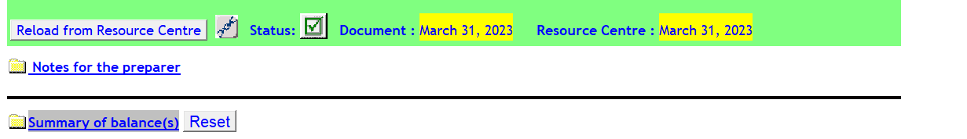
If document date agrees to resource centre, then it’s updated.
- Please ensure all files you work has a JZPCKEY for reviews and compilations and JZPCKEYA for audits
Reviews and compilation

Audits

- Also make sure the path in the JZPCKEY is updates properly
  - For reviews - C:\2_Resources\Knowledge Libraries\PEG Review KLIB
  - For audits - C:\2_Resources\Knowledge Libraries\PEG Audit KLIB
Once the above has been done you will able to update checklists and forms accordingly

- Management questionnaire – the template for the management questionnaire is available under admin letters and templates CaseWare file in the document library. Please send this with your initial planning documents. Please ensure discussion date updated on checklists agree with the date you actually got responses for these questionnaires.
  - For not-for-profit organizations there would be board of directors. In situations like that you would need to send separate questionnaires for management and the board. Instruct the board member to directly provide the response to you or the manager’s email. Refer Q1 and Q2 in screen shot below

- To have a better tracking of questions documents requested and provided by client, consider using the request log. This would useful for audits and reviews. Refer 425 in screen shot below. Please refer to the video on how to use the request log and reach out to Kevin if you have any questions (kschweyer@crawfordss.ca)

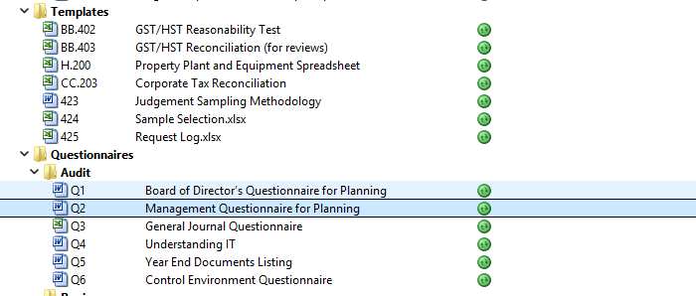

- Please update setting in trial balance sent to client DFC2 to account balance with group subtotal and then open the trial balance and right click and hide annotation. Refer screen shot below. This will be a more presentable version of the trial balance for the client and would not have our annotations.
