 | Thursday, MARCH 6th 10am.

to: | CSS Team
from: | The Audit Group
subject: | Monthly Audit Meeting Memo - MARCH
Summary
Hi all,
See below summarized memo of the audit meeting on March 6th
- To use audit planning letter and audit findings letter for audit files going forward- available in the audit template
  - Audit planning letter – 416F available under planning, Audit findings letter – 345F available under completion documents
  - Please check the following on the audit planning letter
    - Under engagement options- check structure (not for profit/for profit) and entity referred to as (organization or cab customized)
    - Under reporting options – select framework (ASNPO/ASPE)
    - Formatting options – you could opt -client signature
    - Please check engagement letter date agrees to paragraph in the audit planning letter. You could send both letters together with the same date
- Audit Schedule- Please refer audit schedule for any audits or reviews assigned to you. Items highlighted in green means dates are confirmed and items highlighted in yellow means booked tentatively. Please review schedule and reach out to you manager for any audits that are coming up.
  - Location - Z:\00. Audit Schedule

- Using form 520 – Risk Register – Identifying and assessing risks of material misstatements
  - Check if latest form is updated
  - Check if identifier agrees to form number – found under form properties
  - Identify for FSR level risk under Part A – eg : Risk of segregations of duties and management override. Document appropriate audit response (Eg : Substantives testing done, AJE testing done WP – 670)
  - Identify RMM (Risk of Material Misstatements) and assess inherent risk on the assertion level - Part B
    - Please document risk identified for each risk source.
    - Please select SCOTABD impacted from the drop down. See below screen shot (Part B). This will ensure that the risk pulls through to 590
    - Update relevant assertions impacted, fraud risk, assess inherent risk, significant risk, etc
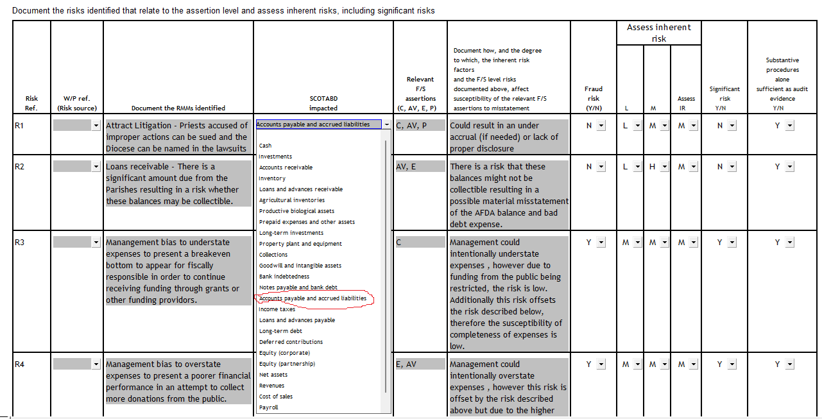
- Using form 590 – Engagement scoping - Classes of transactions, account balances and disclosures
  - This form is used to link the risk identified from 520 and determine the work that needs to be done based on assertion level risks identified
  - Ensure all preliminary L/S (Lead sheet) items are captured. In the right corner there is option to select L/S’s
  - For income statement items, use revenue, payroll and other expenses L/S which has the totals
  - If items are material (above PM) all 4 assertions need to be checked for general procedures done under .100 checklists - see below
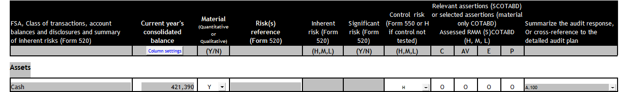
  - If you have identified risk from 520, right click on the transaction at the drop down should show the relevant risk from 520. Then all assertions will indicate as X instead of O as there are specified risks. Then you identify specified assertions that will be tested and mark as H, M or L. and document appropriate audit response to address those risk or cross reference to relevant working paper. See below
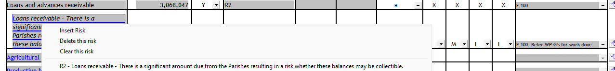
  - Accordingly these identified risks will pull through to the .100 checklist. See below for general low risk with no assessed risk from 520 (see below)

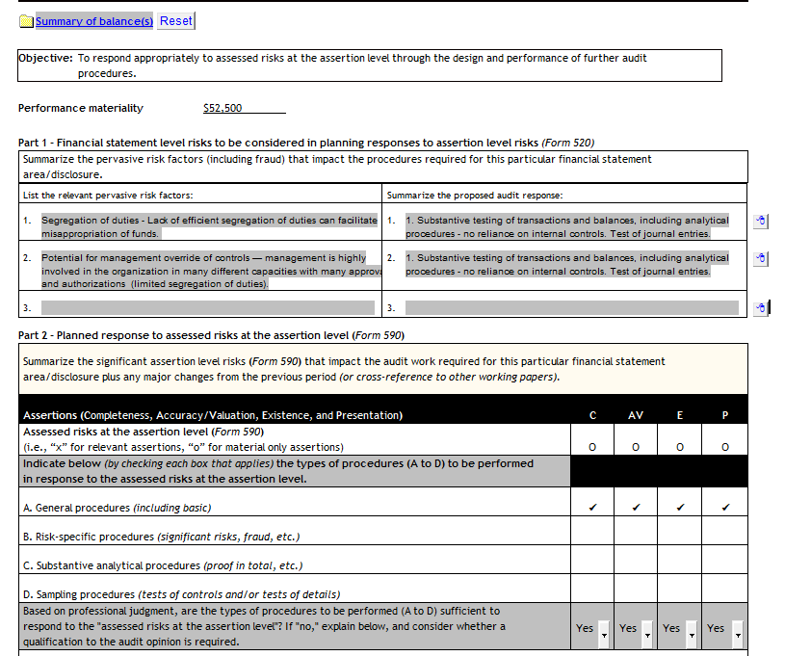

  - See below for general low risk with assessed risk from 520

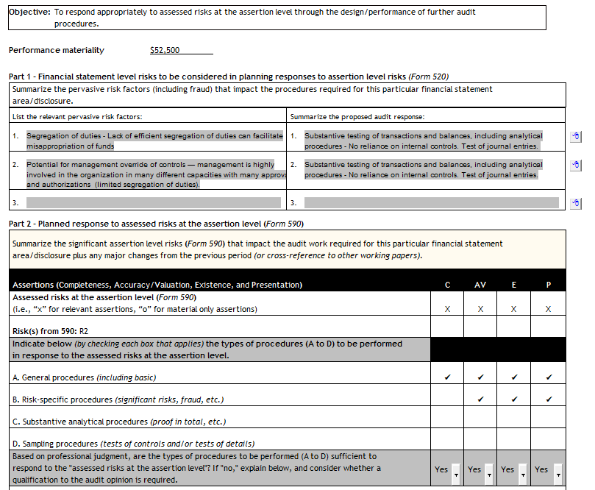

- Confidence factor
  - Confidence factors is based on the level of assurance level we are trying to achieve. See attached template for sample selection. (this will be included in the CaseWare audit template as well by next week)
  - 590 will help to determine the starting risk level H, M, L which will impact the assurance level you are trying to achieve. And from there you can reduce 0.5 for any additional analytical work, reasonability testing and confirmations obtained
  - Number of samples selected = Population/(Performance materiality/Confidence factor)
  - See below assurance level achieved for each confidence factor

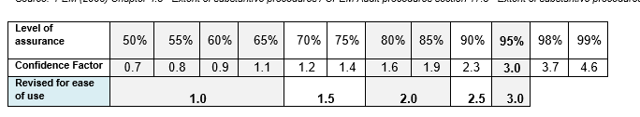

- Additional discussion points. Please refer memo on audit meeting one on the CRA balances which includes GRIP, RDTOH, Capital loss, etc and including CRA account balances which includes tax payable balance at year end

- Finally recorded sessions of monthly audit meeting are now available on Z:\12. Monthly Audit Meetings

Let the audit team if you have any questions

