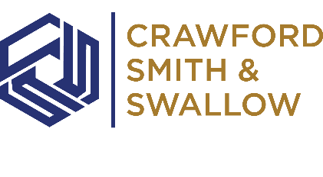 | Thursday, February 6th 10am.

to: | CSS Team
from: | The Audit Group
subject: | Monthly Audit Meeting Memo - February
We had updated our CSS templates for the most recent Jazzit releases of all the forms- audits was version Sept 2024 and compilations and reviews was version Jan 2024.
For audits, the largest changes were in the audit planning letter and the audit findings letter, we had updated these to be in line with the Jazzit templates as there were a lot of changes and we were not fully following what the CAS requirements were (I suspect our letters had not been updated in a while). For compilations and reviews, the templates we had on the network were from 2022. We are pushing everyone to ensure that they are using the most recent Jazzit templates on all files.
Let the Audit Team know if anyone has any questions.
________________________________________________________________________________________________________
Summary
Hi all,
As discussed, see below summary of discussion points from the first monthly audit meeting
- Audit Schedule is saved on Z drive - Z:\00. Audit Schedule. Please review before planning for vacation. Also please reach out to your manager at least two weeks before the starting day of the audit if you have not been contacted already.
- The remote VPN has been updated to SonicWall NetExtender. Please ensure that you have the latest VPN available. This is for remote access when you are out of office. Raise a ticket with Microtech if you don’t have this updated already

- Document library access- Please note both servers have been updated and now have access to Audit, review, compilation and T2 only templates
- All forms have been updated to latest jazz it versions. Audits – September 26th, 2024. Reviews and compilations – January 26, 2024
- Please ensure all files you work has a JZPCKEY for reviews and compilations and JZPCKEYA for audits
Reviews and compilation

Audits

- Also make sure the path in the JZPCKEY is updates properly
  - For reviews - C:\2_Resources\Knowledge Libraries\PEG Review KLIB
  - For audits - C:\2_Resources\Knowledge Libraries\PEG Audit KLIB
- Once the above has been done you will able to update checklists and forms accordingly. Please reach out myself or Kevin if you have any questions.
- These updates to be done on any files starting from February 2025
- Pre Audit letter changed to Audit Planning Letter – included in the audit template
- Post Audit letter changed to Audit Findings Letter – included in the audit template
- Please use the audit, review and compilation templates as guidelines on how the layout of your year end file should be
- Corporate tax reconciliation schedule is now available on the review and compilation template. Please use this schedule for completing the corporate taxes payable section. Also wanted to clarify that under the CC section, you need to include the prior year NOA and the installments. And for the Tax section, include the CRA balances (GRIP balance, Non capital loss, Capital loss, ERDTOH and NEDTOH). I have attached, the CRA balances document for your information and have included the steps to get the report
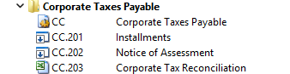

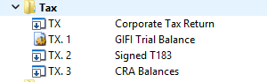
- Finally, there will be a recorded version of the first audit meeting available in our CSS dashboard very soon.
Please reach out to Pat, Kevin or Myself if you have any questions.

